Racing the Tide
by Denise Kirby

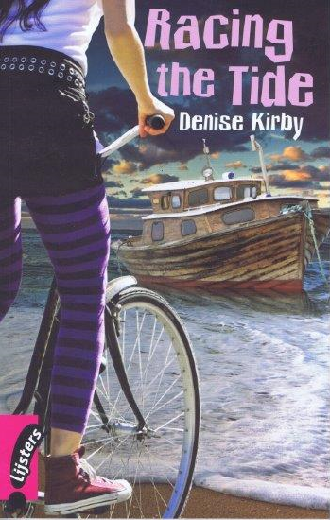

Assignments

Before Reading
- Look at the front cover of your book and describe the picture

- Now look at the back cover and write down the three things that Ella finds unusual in
Broome.
A
B
C

While Reading

Chapter 1 Another beginning

1 ‘Ella lay on her bed and looked at the map of Western Australia.’
Now turn your book upside down and look at the picture. On it you can see the
abbreviations of the Australian states.

What do the letters stand for? You may want to use an atlas or the internet.

A NT
B SA
C NSW
D Vic
E Tas

A |  | B
C | D |  | E

2 Why did Ella’s family live in a caravan?

3 What did Ella hate most about living in the caravan?

4 What was the little green book?

5 Ella had wanted to go on a metalsmithing course in her home town.
What would she have learnt on such a course?

6 Ella and her parents had talked about it until they were ‘blue in the face’.
Explain in English what this means.

7 Here are some more expressions with the word blue in them.
Match the expressions with their meanings.
 | expressions |  | meanings
A | After Daisy left him he was feeling blue | I | very loudly
B | His disappearance came out of the blue | II | belong to a royal family
C | He shouted blue murder | III | a sign that the beach is clean
D | He claims to have blue blood | IV | depressed
E | The blue flag was waving | V | a difficult choice between two evils
F | Between the devil and the deep blue sea | VI | unexpected

A = | B = | C = | D = | E = | F =

8 After reading this chapter can you guess Ella and Eddie’s ages?
Explain your answer.

9 What happened during Ella’s swim?

10 Ella had wanted to go on a metalsmithing course more than anything in the world.
If your parents would offer you to go on a course, what course would you choose? Explain your answer.

Chapter 2 Neighbours

- Why did Ella hate going to the toilet in the middle of the night?

- What did she see on her way to the toilet?

- Look at your answer to Question 9 of Chapter 1.
What had been the reason for what happened during Ella’s swim, according to Barry?

- Ella and Eddie fight a lot.
What is the main reason for their quarrels?

- Who or what was The Wanderer?

- What did Ella find by the side of the road?

- Look at the people in the picture on page 13.
What is your first impression of them?

Chapter 3 The new girl
- What did Ella find the most annoying thing on the first day at her new school?

- Why did Ella sit alone during lunchtime?

- What was Ella surprised to hear from Meg and Tayla?

- How did many people in Broome earn their money?

- A Who is Dora?
B Why did Tayla and Meg call her ‘Crazy Dora’?
A

B

6 Walking outside their caravan Ella had the feeling of being watched.
A Who was watching her?
B And how did she find out?

Chapter 4 Crazy Dora

- Why did Dora not want to talk to Ella at first?

- A Between which wars had Dora’s father been a diver?
B What had he been diving for?
C Why did that business no longer exist?
A
B
C

- How did Tokuichi Kuribayashi save the town of Broome?

- What was strange about the break-in?
5 What four objects have been left out of the picture below?

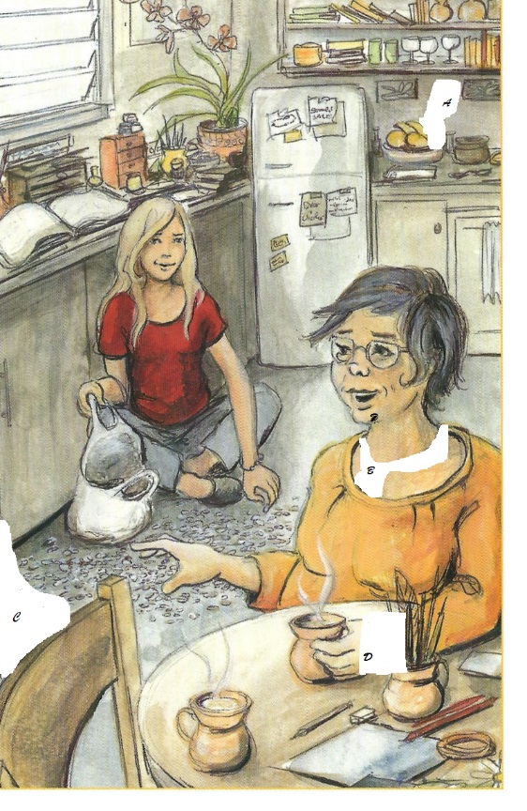

A | B
C | D

Chapter 5 Missing

- Why did Dora suspect Ella of the break-in?

- Why did Dora need the little black book?

- Why did Dora’s face turn white?

- What was the little trip that Jenny’s father, Mr Stevens, was talking about?

- Where are the police officers, Mr Stevens and Ella going at the end of this chapter?

- Below you see the events that were described in this chapter.

A Jenny had arranged to meet Dora on Sunday morning.
B Jenny left home.
C Dora left home.
D Jenny should have arrived at Dora’s house.
E Dora came back home after her trip.

Now fill in the clocks to show at what time these five
events took place or were supposed to have taken place.

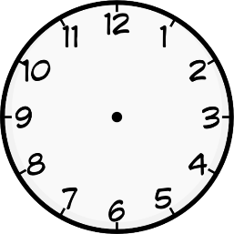
A B C D E
On a digital clock this would be:
a.m | a.m | a.m. | a.m. | p.m

Chapter 6 The search

- What did Bob and Trish Hogan tell the police about Ella finding the bracelet?

- Who are the people in the picture on page 31?
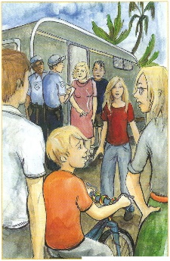
The three people in the foreground of the picture are (from left to right):

---------------------- ----------------------------- ---------------------
The five people in the background of the picture are (from left to right):

----------------------- --------------------------- -------------------

-------------------------- --------------------------

- According to what Ella wrote in her diary, how did the following people react to Ella’s
return in a police car?
Ella’s Mum

Eddie

Ellie’s Dad

Chapter 7 The Pinctada Maxima

- How long had Dora been away on her trip? Explain your answer.

- Why were all the jars broken, according to Ella?

- What is a pearl mother?

- What did Dora have that was made from the Pinctada Maxima?

- What made the pearls less valuable?

- What happened last Sunday morning, according to Ella?

- When did Jenny lose the bracelet, according to Ella?

Chapter 8 A conversation

- What were the Hogans arguing about?

- What do you think Bob meant by saying ‘She’ll tell us’?

- What did Ella need Eddie to stay quiet about?

- Ella took her mother’s mobile phone, ‘just in case’. Just in case of what?

- How did Ella follow the Hogans?

- Why did she have to stop her chase for a moment?

Chapter 9 A night ride

- Ella did not dare to take her eyes off the tail lights. Explain in English what tail lights are.

- Why did Ella get off her bike and hide it behind some bushes?

- Look at the picture on page 44.
A What is the wooden thing that stretches into the sea called?
B Is the tide in or out? Explain your answer.
A
B

- Why had Ella been able to follow the Hogans’ car all the time?

- How did the Hogans make sure their prisoners could not escape?

- Why did the Hogans keep Jenny in the boat?

7 A Why did Jenny finally tell the Hogans what they wanted to know?
B What did she tell them?
A

B

Chapter 10 Jenny

- Look at your answer to Question 6 of Chapter 7
- A Were you right?
B If not, write down what Jenny told Ella.
A
B

- When did Jenny drop the bracelet?

- What did Ella feel silly about?

- What was the next thing she must have felt silly about?

- Jenny told Ella, ‘And the floor doesn’t look very ________ .‘
A Complete Jenny’s sentence.
B Was she right? Explain your answer.
A
B

- What is Jenny afraid of at the end of this chapter?

- Suppose Jenny and Ella found what they were looking for and were able to send a text
message.
A Who would they send this text message to?
B Write this text message. Use no more than 40 to 50 words.
A
B

Chapter 11 Eddie

- Back at the caravan, who is looking for what?
A | Ella’s mother is looking for a for Eddie and for her .
B | Ella’s father is looking for his
C | Eddie is looking for his

- Why was Ella’s Mum in such a hurry?

- What do you think Eddie should have done after reading Ella’s latest diary entry?

4 A Back at the boat, why did Ella press 000?
B What would she have told them?
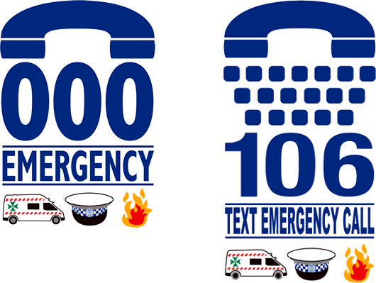 C Did she succeed? Why (not)?
A

B

C

5 Why is Jenny more desperate than Ella?

6 A How did the girls want to escape at first?
B When this was unsuccessful, what were they trying to do next?
A

B

- Look at the picture on page 54.
A What is the red and white thing above Jenny’s head?
B What is it used for?


Chapter 12 Deep water

- Why did Ella feel responsible for the situation she and Jenny were in?

- What would be dangerous in getting out of the boat headfirst?

- How was Ella going to get Jenny out of the boat?

- What was the trouble in doing so?
- Who came to their rescue?

6 What school rule had Eddie broken?
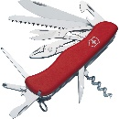

- Have a look at your answer to Question 6.
Write down at least 3 tools that you can find on such an object.

- Here is some information about the history of such an object.
Read the text and answer the questions.

Victorinox
1884
Karl Elsener I opens a knife cutler’s workshop in Ibach-Schwyz. His mother Victoria actively supports him in his endeavors.
1891
Karl Elsener is able to deliver the first major supply of soldier’s knives to the Swiss Army.
1897
The original Swiss Officer’s and Sports Knife is patented.
1909
Karl Elsener registers the emblem with the cross and shield as a trademark.
1921
The invention of stainless steel is a highly significant development for the cutlery industry. “Inox” is the international term for stainless steel.
1945
The Swiss Army Knife becomes known all over the world. U.S. soldiers stationed in Europe buy it in large quantities and it begins to be a popular souvenir to take home.
1984
Under its Swiss Army brand, Victorinox enters the North American watch business.
1999
Victorinox enters the international travel gear market.
2001
Victorinox launches a clothing line in the U.S..
2007
Victorinox Swiss Army Fragrance starts a perfume line.
2008
Victorinox opens the first Flagship store in Europe at
New Bond Street, London.

A How did this object get its brand name?
B Draw this object’s emblem.
C In what other lines of business is Victorinox active? Mention at least 3.
D What is a flagship store?

A | Victor = |  | Inox =
B

C | 1 | 2 |  | 3
D

9 How did Eddie know where to go after they had driven around?

10 A What had the Hogans done in the meantime?
B What happened to them?
A

B

11 How was Ella rewarded?

After Reading

- Have another look at the front cover of your book. In what way is this picture incorrect?

- At first Ella was not very happy about leaving her hometown and moving to Broome.

A Suppose you were to move in the near future, how would you feel about that? Explain your answer.
B And, what if you were to move abroad,
I what could be a possible reason for this?
II what would be your favourite country to move to? Explain your answer.
A
B I
B II

→ → →

- And what about emigrating to Australia? Solve this word search to prepare yourself for this move!

Australia
Find and circle all of the words that are hidden in the grid.
The remaining 49 letters spell a secret message.
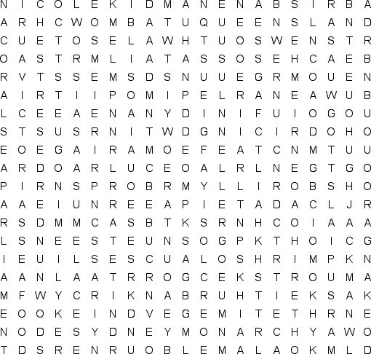
ADELAIDE  AUSSIE  BEACHES  BOOMERANG  BRISBANE  CANBERRA  COMMONWEALTH  CONTINENT  CORAL SEA  CROCODILES  DESERTS |  | DIDGERIDOO  DINGO  DOWN UNDER  EMUS  EUCALYPTUS TREES  HUGH JACKMAN  KANGAROO  KEITH URBAN  KOALA  KOOKABURRA  KYLIE MINOGUE |  | MARSUPIALS  MELBOURNE  MONARCHY  NEW SOUTH WALES  NICOLE KIDMAN  OCEANS  OUTBACK  PARLIAMENT  PERTH  PLATYPUS  PRIME MINISTER |  | QUEENSLAND  RAINFORESTS  RUSSELL CROWE  SEAFOOD  SHRIMP  SURFING  SYDNEY  TASMANIA  VEGEMITE  VICTORIA  WOMBAT

The hidden message is:

